**A000-AM,S-Peru-Chavin Jaguar Effigy Mortar-ca 300 BCE**

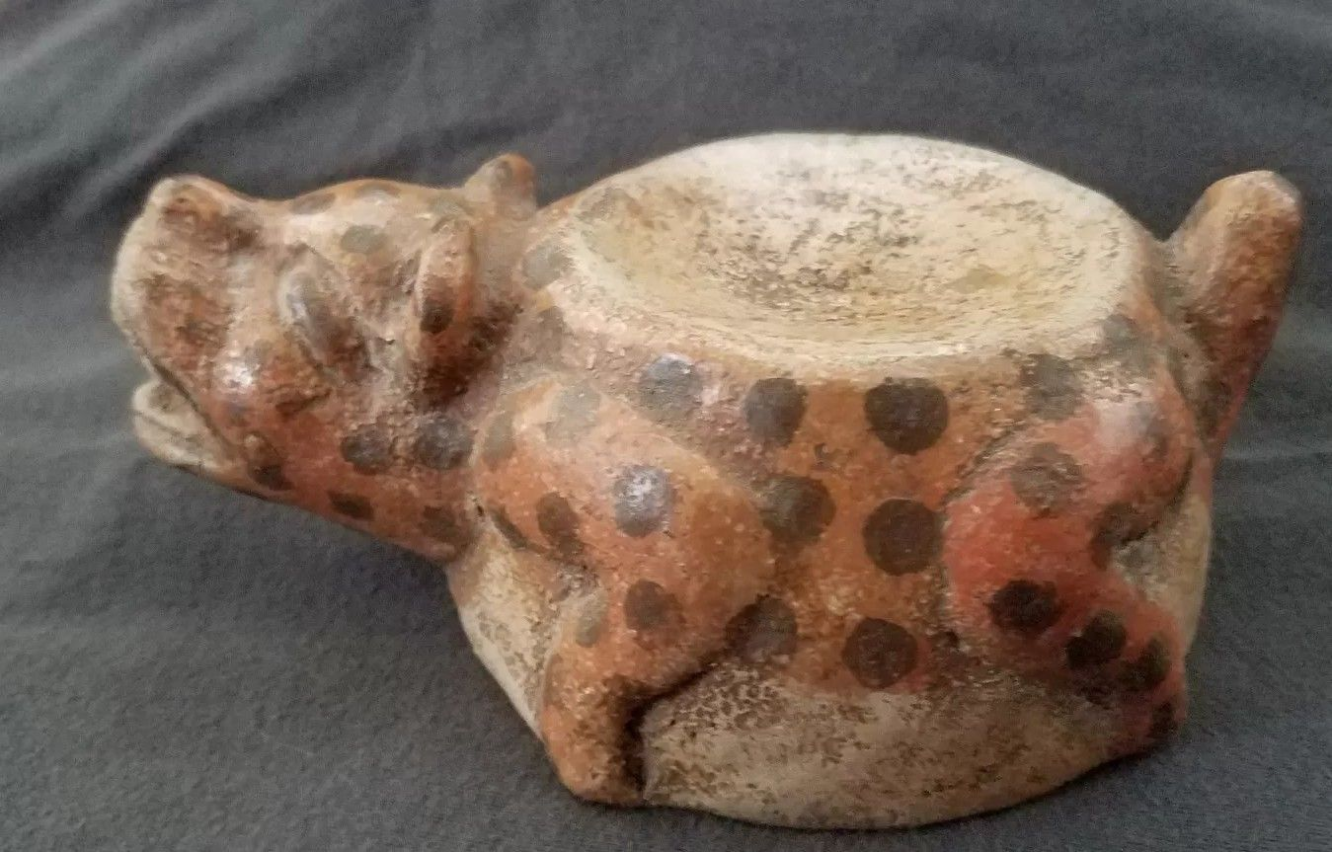

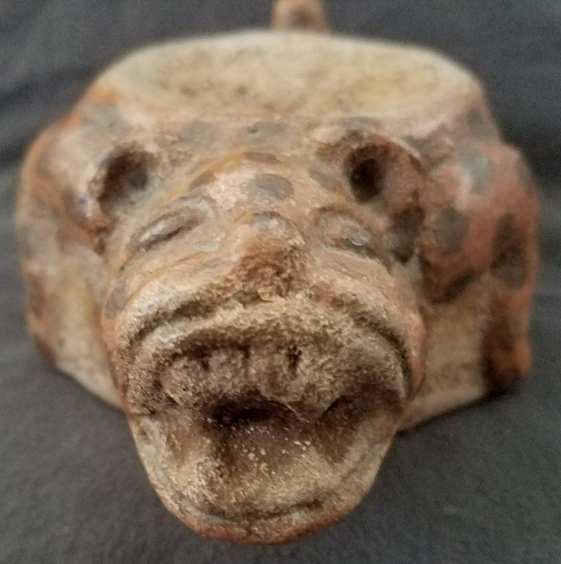 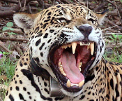

Right <https://cdn.zmescience.com/wp-content/uploads/2017/02/1200px-Jaguar_Panthera_onca_palustris_male_Rio_Negro_2.jpg>

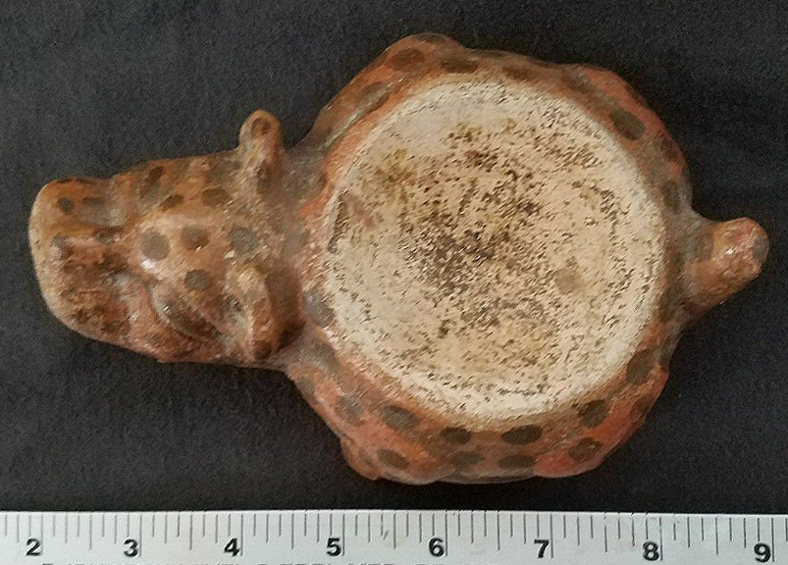

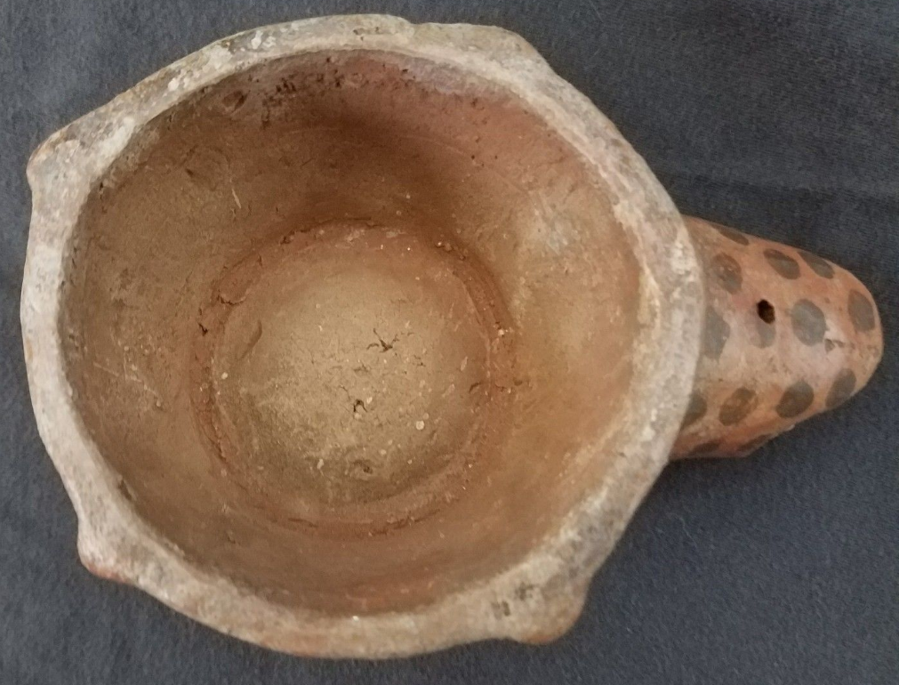

Figs. 1-4. **Peru, Chavín Jaguar Effigy Mortar, ca 300 BCE**

**Case No.: 14**

**Accession No.**

**Formal Label: Peru, Chavín Jaguar Effigy Mortar, ca 300 BCE**

**Display Description:**

This spotted jaguar effigy mortar evokes the Chavín art that decorates the walls of the main temple at Chavín de Huantar with carvings, sculptures and pottery depicting exotic creatures, such as jaguars, one of the most important animals that had significant religious implications and is repeated on many carvings and sculptures such as this jaguar effigy mortar. The jaguar represented expertise in hunting and in combat: the perfect animal in complete symbiosis with nature able to capture virtually any other animal. Thus, the ideal warrior should merge with the soul of the jaguar to become one with him. Similarly, Pre-Columbian peoples viewed the hunter as a jaguar, who had assimilated the skill, strength, cunning, serenity, determination and precision of this animal master. Therefore, the jaguar was the most revered deity.

Garagay, a site in the Lima region, was inspired by Chavín iconography and religion. On display in the main temple is a head with mucus coming from the nostrils suggestive of the use of ayahuasca (or *ayawaska)*, an entheogenic brew made of the *Banisteriopsis caapi* vine and the *Psychotria viridis* leaf. This mortar may have been used to prepare this brew, which would be consistent with its jaguar iconography. An entheogen is any chemical substance used in a mystical, religious, shamanic, or spiritual context that induces psychological or physiological experiences that generate a spiritual experience.Linguistically, *Aya* means spirit, soul, corpse, dead body, and *waska* means rope and woody vine of the liana. Combined it is translated as the rope of the dead, referring to the act of dying to one’s rational soul and being awakened in one’s true spiritual soul. Ayahuasca is used as a traditional entheogenic concoction in ceremonies among indigenous peoples of greater Amazonia, especially as they sought to merge with the jaguar spirit.

* **LC Classification:** F3429.1.C48

**Date or Time Horizon:** 900 BCE - 200 BCE

**Geographical Area:** near Chavín de Huantar, Ancash Region, Peru

**Map:**

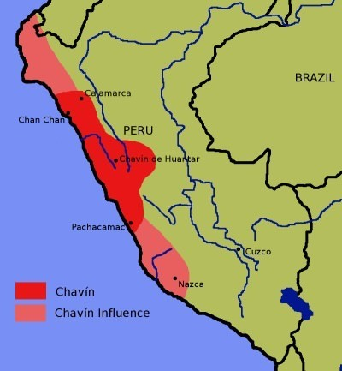

Fig. 5. Location of Chavín de Huantar after https://www.ancient.eu/img/r/p/500x600/3758.jpg?v=1485681341.

**GPS coordinates:** [9°35′34″S 77°10′42″W](https://tools.wmflabs.org/geohack/geohack.php?pagename=Chav%C3%ADn_de_Huantar&params=9_35_34_S_77_10_42_W_type:landmark)

**Cultural Affiliation:** Chavín, a major pre-Inca Andean culture

**Medium:** Marble

**Dimensions:** **L** **7 in**

**Weight:**

**Provenance:** Lelar Rauri, Lima, Peru

**Condition: Museum Quality**

**Discussion:** The example of the architecture of the Chavín de Huantar temple demonstrates complex innovations implemented to adapt to the highland environments of Peru. In order to avoid the temple's being flooded during the rainy season, Chavín people engineered a system that involved drainage canals under the temple.

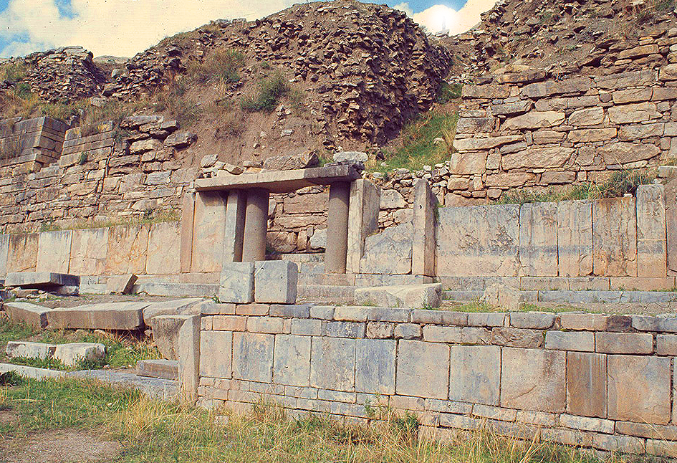

Fig. 6. The Chavín de Huanta*r* temple portico. After http://nmai.si.edu/inkaroad/img/ancestors/beginningsoftheroad/chavin-temple.jpg

The Chavín people also showed advanced acoustic understanding and applied it to their spiritual ritual. During the rainy season water rushes through the underground canals creating a roaring sound and creates a noise like a jaguar, a sacred animal. It was during this season that special plants like ayahuasca were ground in jaguar mortars like this one and then offered to the people attending the jaguar rituals.

Since the temple was built of white granite and marble which are not native to the region, these special materials were procured from distant sources. This procurement of distant materials is indicative of Chavín culture’s wide sphere of trade and cultural influence, since it was located at a trade rendezvous point between the deserts and the Amazonian jungle. For example, Pacopampa, among the largest ceremonial centers of the northern highlands of Peru which was active during the Formative period (1200 to 500 BCE), is reached by a three-week journey north of Chavín de Huantar, and it shows the influence of Chavín culture in its renovations on the main temple. Similarly, Caballo Muerto, a coastal site in the Moche Valley region that spanned both the Initial Period (2100–1200 CAL BCE) and the Early Horizon Period (1200–200 CAL BCE) utilized Chavín inspired adobe structure in the renovation of its main temple.

**References:**

Burger. Richard L. 1992 a. *Chavín and the Origins of Andean Civilization,* London: Thames and Hudson, 1992.

Burger. Richard L. 1992 b. “The Sacred Center of Chavín de Huántar” in *The Ancient Americas: Art from Sacred Landscapes*, ed. by R.F. Townsend. Chicago: The Art Institute of Chicago, pp. 265-77.